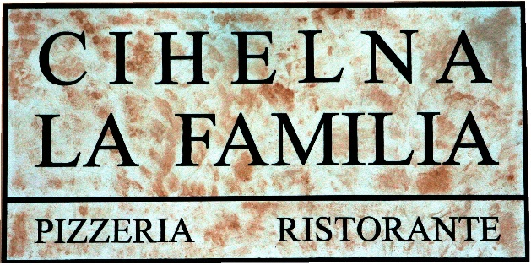

A list of allergens is available on request from the staff

CZECH CUISINE SPECIALTIES

ROAST DUCK LEG 200g
duck leg baked until golden brown with red cabbage
and homemade Karlovy vary dumpling
279 Kč

SIRLOIN IN CREAM SAUCE 180g
beef sirloin in cream larded with bacon,
bread dumplings, lemon target
239 Kč

GOULASH CIHELNA 150g
Homemade beef goulash with bread dumplings and onion
239 Kč

KARLÍN Sparrow 150g
pork roasts with spinach
and potato dumplings, garnished with fried onions
219 Kč

ROAST PORK RIBS 700g
with Barbecue sauce, Dijon mustard, horseradish,
lamb horns and pizza bread
279 Kč

STARTERS / ANTIPASTI

1 SALMONE ALLA TARTARA 90g 219 Kč
fine pieces of fresh salmon mixed with onion, parsley, lemon, capers, olive oil, served with pickled ginger

2 BRUSCHETTA AL POMODORO 139 Kč
fresh tomatoes and black olives flavored with olive oil,
served on toasted homemade bread with Mozzarella Buffala
garnished with fresh basil
3 TAGLIERE MISTO FORMAGGI 200g 229 Kč
variation of Italien cheses Gorgonzola, Pecorino, Talegio,
Mozzarella and Parmesan on stone
4 INSALATA CAPRESE CON BUFFALA 165 Kč
slices of fresh tomatoes lined with Mozzarella Buffala,
flavored with olive oil and fresh basil

5 GAMBERETTI 120 g 265 Kč
spicy shrimps on garlic, white wine, chili peppers and cayenne pepper with pizza bread

6 CARPACCIO CON PARMIGIANO 90g 275 Kč
marinated thin slices of beef sirloin with arugula, pesto, capers
and Parmesan shavings

7 CALAMARI GRIGLIATI E SPINACI FRESCO 100g 239 Kč
calamari grilled on garlic, white wine and brandy with sun-dried tomatoes, spinach leaves, balsamic reduction and homemade bread

10 HOMEMADE PIZZA BREAD AND BUTTER 65 Kč

SOUPS / ZUPPE
22 ZUPPA DI POMODORO 85 Kč
tomato soup with cream

23 ZUPPA DI MANZO 85 Kč
strong beef broth with noodles and vegetables

24 BORŠČ 99 Kč
thick beetroot soup with meat and cream
LARGE SALAD BOWLS / INSALATE GRANDI

31 INSALATA CAESARE 90g 229 Kč
slices of grilled chicken breast and Pancetta,
cherry tomatoes, croutons served on Roman leaves with Parmesan shavings, flavored with anchovie dressing
32 INSALATA CAPITANO 239 Kč
grilled goat cheese with arugula and romaine lettuce salad
with caramelized pear in brandy, walnuts,
marinated carrots and balsamic dressing

34 INSALATA SALMONE 249 Kč
grilled salmon on a salad of romaine lettuce, arugula and cherry tomatoes flavored with lemon pesto

35 INSALATA STEAK & SALAT 100g 265 Kč
rucola salad with olives, marinated red onion, Pancetta, dried tomatoes with slices of grilled Argentine meats and French mustard dressing

SMALL SALAD BOWLS / INSALATE PICCOLE
45 INSALATA DI POMODORI 95 Kč
tomato salad
46 INSALATA GRECA 119 Kč
Greek salad

47 INSALATA MISTA 99 Kč
mixed salad

PIZZA NAPOLITANA (thin dough) ∅ 33 cm

We produce from original Italian ingredients !!!
Bake in a stone oven on oak and beech wood.

50 MARGHERITA ORIGINALE 249 Kč
sugo al pomodoro, Mozzarella Buffala, fresh basil
51 FOCACCIA (we recommend for starters) 89 Kč
extra virgin olive oil, garlic, rosemary
52 SCALOPPINA 269 Kč
cream, Mozzarella, spicy pork tenderloin,
grilled onions, parmesan shavings
53 MARGHERITA 185 Kč
sugo al pomodoro, Mozzarella, fresh basil

54 CAMEMBERT 239 Kč
cream, mozzarella, bone-in ham, camembert, cranberries

55 PROSCIUTTO COTTO 219 Kč
sugo al pomodoro, Mozzarella, bone-in ham

56 CAPRICCIOSA 239 Kč
sugo al pomodoro, Mozzarella, bone-in ham,
mushrooms, olives

57 PROSCIUTTO E FUNGHI 255 Kč
sugo al pomodoro, Mozzarella, bone-in ham
and fresh mushrooms
58 VEGETARIANA 207 Kč
sugo al pomodoro, Mozzarella, spinach, garlic, grilled peppers, mushrooms and corn
59 DIAVOLA CON TALEGGIO 245 Kč
sugo al pomodoro, Mozzarella, salami Ventricina piccante,
Taleggio cheese, pepper “lamb horns“

61 QUATTRO FORMAGGI BIANCO 239 Kč
cream, mozzarella, Taleggio cheese, gorgonzola, parmesan

62 TONNO, UOVA E CIPOLLA 225 Kč
sugo al pomodoro, mozzarella, tuna, eggs, red onion, olives


63 BELZEBUBBO 299 Kč
tomato sauce, pepperoni, Mozzarella, Ventricina salamipiccante, tyrolský špek, Parmezán, Jalapeňos, feferonky, červená cibule

64 AL POLLO 229 Kč
cream, mozzarella, marinated chicken pieces, corn,
broccoli and Gorgonzola
65 MESSICO 249 Kč
tomato sauce, Mozzarella, salami Ventricina piccante,
bone-in ham, corn, onions

66 HAWAI 225 Kč
sugo al pomodoro, Mozzarella, bone-in ham, pineapple

67 CARPACCIO 289 Kč
sugo al pomodoro, Mozzarella, marinated slices of real sirloin, arugula, parmesan shavings

68 LA FAMILIA 289 Kč
tomato sauce, Mozzarella di Bufala, mushrooms, Pancetta,
arugula and parmesan shavings
d
69 PECORINO 239 Kč
cream, Mozzarella, sheep cheese, Pancetta and arugula

EXTRA INGREDIENTS FOR PIZZA AND OTHER MEALS

91 Meat I. 50g – bone - in ham, chicken, tuna, anchovies 49 Kč
92 Meat II. 50g – Tyrolean bacon, Italian salami Schiacciata piccante 65 Kč
pork tenderloin, real sirloin
93 Cheese 50g – Mozzarella, parmezán, Gorgonzola, Taleggio 49 Kč
94 Cheese 50g – Mozzarella Buffala 105 Kč
95 Vegetables 30g– olives, artichokes, mushrooms, tomatoes, asparagus, spinach 49 Kč

FRESH HOMEMADE PASTA / PASTA FRESCA
(we make our own pasta - fresh every day)

101 SPAGHETTI ALLA BOLOGNESE 225 Kč
meat ragout with fresh herbs in tomato sauce
with parmesan shavings

102 SPAGHETTI ALLA CARBONARA 215 Kč
Roasted Pancetta with egg, cream and Parmesan shavings
103 SPAGHETTI AGLIO, OLIO E PEPERONCINO 189 Kč
garlic, and chili peppers in olive oil with parmesan shavings

105 FUSILLI AL SALMONE 239 Kč
pieces of salmon in white wine with tomatoes, red onion and ginger

106 FUSILLI MAFIOSI 289 Kč
slices of beef on rosemary with cherry tomatoes, olive oil, chilli, garlic and mozzarella

108 PAPPARDELLE POLLO E SPINACI 225 Kč
chicken breast with spinach, garlic, cream and parmesan

109 PAPPARDELLE CON POLLO E BROCCOLI 235 Kč
pasta with chicken, broccoli, garlic, softened with cream and flavored with gorgonzola cheese

110 PAPPARDELLE VERDI AI FUNGHI PORCINI 239 Kč
pasta with cream sauce, porcini mushrooms, Pancetta and garlic with Parmesan shavings

POTATO GNOCCHI / GNOCCHI DI PATATE

121 GNOCCHI DI PATATE CON POMODORO E POLLO 239 Kč
potato dumplings with chicken in white wine and butter, cherry
tomatoes, pomodoro sauce, chili, garlic, olives, oregano, pickled pepper, garnished with arugula and Parmesan shavings
122 GNOCCHI AI QUATTRO FORMAGGI 249 Kč
potato dumplings with Gorgonzola, mozzarella,
Taleggio cheese, Parmesan shavings and cream

133 GNOCCHI MAIALE 239 Kč
potato dumplings with grilled pork terderloin, spinach,
cream and Parmesan

134 GNOCCHI ALLA LILIJE 289 Kč
potato dumplings with sliced of beef flank steak, broccoli,
fox mushrooms, garlic, onion and Parmesan

BAKED PASTA / PASTA AL FORNO

131 LASAGNE ALLA BOLOGNESE 249 Kč
pasta baked with meat ragout in tomato sauce,
mozzarella and parmesan

132 GNOCCHI PANNA E SALMONE 249 Kč
potato dumplings baked with pieces of smoked salmon, butter,
spinach, garlic, cream and parmesan

RISOTTO / RISOTTI

142 RISOTTO AI FUNGHI PORCINI 255 Kč
Italian rice Arborio with porcini mushrooms, Pancetta, softened with truffle oil and sprinkled with Parmesan

143 RISOTTO SAPORITO 265 Kč
Italian Arborio rice with pork loin, Pancetta, mushrooms, garlic, rosemary and parmesan

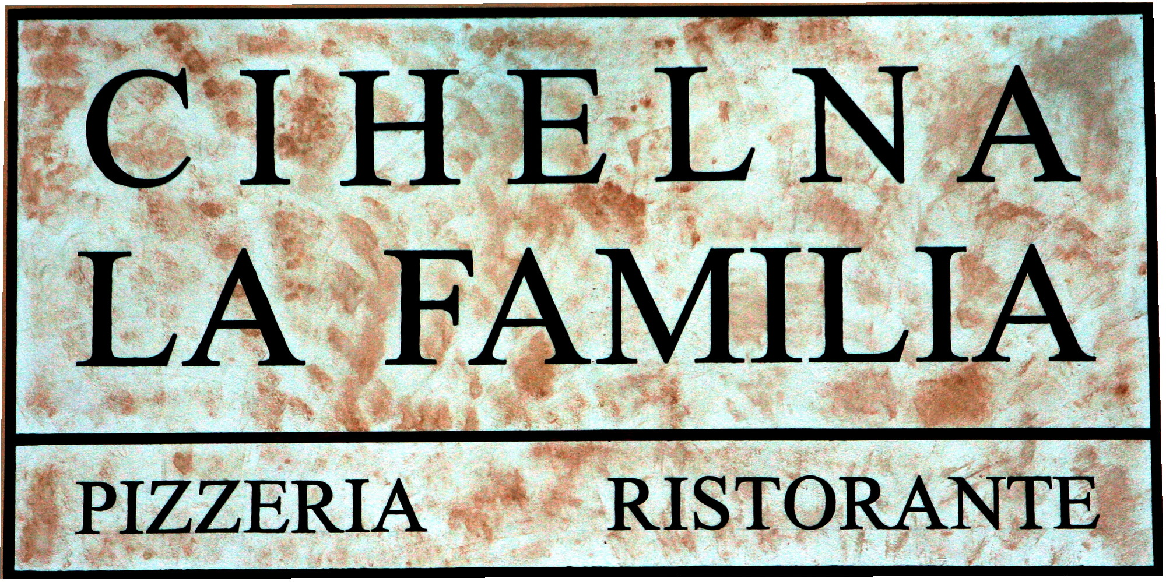

BISTECCA
The minimum time of meat preparation is 30 minutes

151 FLANK STEAK 200g 415 Kč
filleted beef belly button with onion rings and herb sauce

152 COSTATTA ARGENTINA 220g 459 Kč
Argentinian Rump steak with gratinated potatoes stuffed with Chedar cheese, bacon and egg

MEAT WITH SIDE DISH / CARNE CON CONTORNO

163 FETINE DI POLLO 200g 355 Kč
slised chicken breast in sesame crust with beans on onion
and garlic with Chedarr sauce

164 PADELLA DI POLLO 200g 345 Kč
chicken lightly spicy pan with a beans, musrooms, peppers, onion and steak fries

166 MEDAGLIONE DI MAIALE 200g 379 Kč
pork lion medallions with homemade croquettes and fox musroom sauce

171 HAMBURGER ALLA CHEF 200g 295 Kč
beef burger with romaine lettuce, fresh tomatoes,
Pancetta, Chedarr, onions, french fries and Mississippi sauce

FISH / PESCE

181 SALMONE ,,TERIYAKI,, 180g 399 Kč
fresh salmon with Japanese Teriyaki sauce, garnished with pink ginger and shrimp, served with jasmine rice

KIDS MENU / MENU DI BAMBINI
We offer a children's menu only for children. It is not possible to order for an adult!

205 CHICKEN FRIED STEAK 100g 125 Kč
with french fries
DESSERT / DOLCI
201 TIRAMISU 129 Kč
traditional homemade italian dessert

203 APPLE HOMEMADE STRUDEL WITH VANILLA ICE CREAM AND WHIPPED CREAM 125 Kč

204 DESSERT ACCORDING TO THE DAILY OFFER 125 Kč

HOMEMADE LEMONADES 0,4l 89 Kč
• raspberry, ginger, cucumber

HOT DRINKS / BEVANDE CALDI
221 ESPRESSO MISCELA D´ORO 69 Kč
222 ESPRESSO MISCELA D´ORO DOPPIO (double) 129 Kč
223 ESPRESSO DECOFEINATO (without caffeine) 69 Kč
224 CAPPUCCINO 75 Kč
225 LATTE MACCHIATO 79 Kč
226 ESPRESSO MACHIATO 69 Kč
227 CAFFE ALGERINO 89 Kč
coffee with egg liqueur and whipped cream
228 CAFFE VIENNESE 89 Kč
229 ICE CAFFE with vanilla ice cream 109 Kč
230 CHOCOLATA CALDA 79 Kč
Italian milk white or dark chocolate with whipped cream
232 GROG 99 Kč
4 cl Tuzemák, hot water, lemon
233 0,2 l Mulled wine 119 Kč
red or white wine

TEA / IL TÉ

240 TEA BAG SELECTION 55 Kč

241 FRESH MINT TEA WITH HONEY 79 Kč
242 FRESH GINGER TEA WITH HONEY 79 Kč

DRAFT BEER / BIRRA ALLA SPINA

259 0,3 l PILSNER URQUELL 12% 42 Kč
260 0,5 l PILSNER URQUELL 12% 70 Kč
261 0,3 l BOHÉM 11% KRUŠOVICE 39 Kč
262 0,5 l BOHÉM 11% KRUŠOVICE 65 Kč
263 0,3 l KRUŠOVICE – NA 30 Kč
264 0,5 l KRUŠOVICE – NA 49 Kč

NONALCOHOLIC DRINKS / BEVANDE NON ALCOOLICI

271 0,33 l Coca-Cola, light, zero 59 Kč
272 0,33 l Fanta orange 59 Kč
273 0,33 l Sprite 59 Kč
274 0,25 l Tonic 59 Kč
276 0,25 l Tonic GINGER 59 Kč
277 0,30 l Natura still, sparkling, slightly sparkling 59 Kč
278 0,25 l Fuzetea peach, lemon, green tea 59 Kč
279 0,25 l RED BULL (can) 79 Kč
281 0,25 l Cappy multivitamin, orange, apricot 65 Kč
grapefruit, strawberry, apple, pineapple, pear
290 0,5 l RÁDLER – nealko plech 59 Kč
291 0,2 l CARAFE OF WATER 10 Kč
292 0,5 l CARAFE OF WATER 29 Kč

APERITIVES / APERITIVI
292 1 dcl MARTINY dry, bianco 99 Kč
293 4 cl CAMPARI 99 Kč

SPIRITS ŽUFÁNEK
297 4 cl plum 99 Kč
298 4 cl pear 99 Kč

DISTILLATES AND LIQUEURS / ALCOLICI
303 4 cl ABSINTH 70% 89 Kč
305 4 cl TEQUILA OLMECA blanco, gold 99 Kč
306 4 cl BECHEROVKA, lemon 79 Kč
307 4 cl RUM BACARDI blanco, black, gold 85 Kč
308 4 cl HAVANA ANEJO blanco 85 Kč
309 4 cl CAPT. MORGEN SPICES gold 95 Kč
310 4 cl RUM DIPLOMÁTICO RESERVA 119 Kč
311 4 cl TUZEMÁK 65 Kč
312 4 cl RUM REPUBLIKA 89 Kč
313 4 cl GIN BEEFEATER 95 Kč
314 4 cl MALIBU 89 Kč
316 4 cl VODKA FINLADIA 89 Kč
317 4 cl PEPRMINT zelená 55 Kč
319 4 cl JAGERMEISTER 89 Kč
323 4 cl FERNET stock, citrus 79 Kč
324 4 cl BAILEYS 85 Kč

WHISKY & BOURBON
344 4 cl JAMESON, TULAMORE 105 Kč
345 4 cl JACK DANIELS classic, honey 115 Kč
346 4 cl JIM BEAM BOURBON, honey 105 Kč

GOGNAK & BRANDY
354 4 cl METAXA 115 Kč
355 4 cl COGNAC A. DE FUSSIGNY 499 Kč

SEKTY / SPUMANTI
362 0,75 l BOHEMIA demi sec, brut 399 Kč

CHAMPAGNE
371 0,75 l MOET & CHANDON BRUT IMPERIAL 2290 Kč

WHITE MORAVIAN WINE PAVLOV
384 0,75 l SAVIGNON – late harvest 485 Kč
385 0,75 l RULANSKÉ ŠEDÉ – selection of grapes 485 Kč
386 0,75 l CHARDONNAY – late harvest 485 Kč

RED WINES
391 0,75 l FRANKOVKA archetyp Michlovský 439 Kč
392 0,75 l MODRÝ PORTUGAL Michlovský 439 Kč

ITALIAN WINES / VINO DI ITALIA
A selection of Italian wines can be found in the extra wine list

ALKO MIXED BEVERAGES / COCATAILS ALCOOLICI

411 PIÑA COLADA 149 Kč
Bacardi rum Blanca, coconut syrup, pineapple juice, cream

412 APEROL 120 Kč
Aperol, prosecco, soda

418 CUBA LIBRE 155 Kč
Havana Anejo blanco, limejuice, coca-cola, lime

WE ACCEPT FOOD AND PIZZA ORDERS UNTIL 22:30

