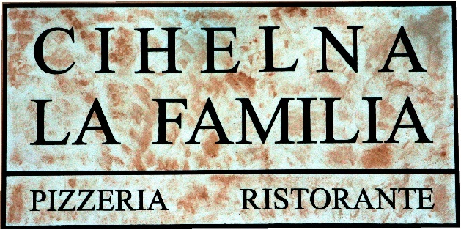

A list of allergens is available on request from the staff

CZECH CUISINE SPECIALTIES

SIRLOIN IN CREAM SAUCE
beef sirloin in cream larded with bacon,
bread dumplings, lemon target
195 Kč

GOULASH CIHELNA
Homemade beef goulash with bread dumplings and onion
195 Kč

KARLÍN Sparrow
pork roasts with spinach
and potato dumplings, garnished with fried onions
189 Kč

ROAST PORK SMOKED RIBS "Tips" 700g
with Barbecue sauce, Dijon mustard, horseradish,
lamb horns and pizza bread
249 Kč

STARTERS / ANTIPASTI

1 SALMONE ALLA TARTARA 90g 195 Kč
fine pieces of fresh salmon mixed with onion, parsley, lemon, capers, olive oil, served with pickled ginger

2 BRUSCHETTA AL POMODORO 125 Kč
fresh tomatoes flavored with olive oil, garlic,
served on homemade bread, sprinkled with Parmesan shavings
and fresh basil
3 BRUSCHETTA AL CAPRA 165 Kč
baked homemade bread with goat cheese and grilled peppers
with arugula and basil pesto
4 INSALATA CAPRESE 129 Kč
slices of fresh tomatoes lined with mozzarella,
flavored with olive oil and fresh basil

5 SPIEDINO DI GAMBERETTI 120 g 229 Kč
spicy shrimps on garlic, white wine, chili peppers and cayenne pepper with pizza bread

6 CARPACCIO CON PARMIGIANO 90g 239 Kč
marinated thin slices of beef sirloin with arugula, pesto, capers
and Parmesan shavings

7 CALAMARI GRIGLIATI E SPINACI FRESCO 100g 209 Kč
calamari grilled on garlic, white wine and brandy with sun-dried tomatoes, spinach leaves, balsamic reduction and homemade bread

10 HOMEMADE PIZZA BREAD AND BUTTER 55 Kč

SOUPS / ZUPPE
22 ZUPPA DI POMODORO 65 Kč
tomato soup with cream

23 ZUPPA DI POLLO 65 Kč
strong chicken broth with homemade noodles and vegetables

24 BORŠČ 75 Kč
thick beetroot soup with cream

25 ZUPPA DEL GIORNO 55 Kč
Soup of the day

LARGE SALAD BOWLS / INSALATE GRANDI

31 INSALATA CESARE 90g 199 Kč
slices of grilled chicken breast and Pancetta,
cherry tomatoes, croutons served on Roman leaves with Parmesan shavings, flavored with Cesare dressing
32 INSALATA CAPITANO 209 Kč
grilled goat cheese with arugula and romaine lettuce salad
with caramelized pear in brandy, walnuts,
marinated carrots and balsamic dressing

34 INSALATA SALMONE 219 Kč
grilled salmon on a salad of romaine lettuce, arugula and cherry tomatoes flavored with lemon pesto

35 INSALATA STEAK & SALAT 229 Kč
arugula salad with olives, marinated red onions,
Pancetta, sun-dried tomatoes with slices of grilled Argentinian meat
and French mustard dressing

SMALL SALAD BOWLS / INSALATE PICCOLE
45 INSALATA DI POMODORI 85 Kč
tomato salad
46 INSALATA GRECA 105 Kč
Greek salad
47 INSALATA MISTA 85 Kč
mixed salad

PIZZA NAPOLITANA (thin dough) ∅ 33 cm

We produce from original Italian ingredients !!!
Bake in a stone oven on oak and beech wood.

50 MARGHERITA ORIGINALE 219 Kč sugo al pomodoro, Mozzarella di Bufala, fresh basil
51 FOCACCIA (we recommend for starters) 79 Kč
extra virgin olive oil, garlic, rosemary
52 SCALOPPINA 239 Kč
cream, Mozzarella, spicy pork tenderloin,
grilled onions, parmesan shavings
53 MARGHERITA 159 Kč
sugo al pomodoro, Mozzarella, fresh basil

54 CAMEMBERT 209 Kč
cream, mozzarella, bone-in ham, camembert, cranberries

55 PROSCIUTTO COTTO 185 Kč
sugo al pomodoro, Mozzarella, bone-in ham

56 CAPRICCIOSA 205 Kč
sugo al pomodoro, Mozzarella, bone-in ham,
mushrooms, olives

57 PROSCIUTTO E FUNGHI 195 Kč
sugo al pomodoro, Mozzarella, bone-in ham
and fresh mushrooms
58 VEGETARIANA 180 Kč
sugo al pomodoro, Mozzarella, spinach, garlic, grilled peppers, mushrooms and corn
59 DIAVOLA CON TALEGGIO 209 Kč
sugo al pomodoro, Mozzarella, salami Ventricina piccante,
Taleggio cheese, pepper “lamb horns“

61 QUATTRO FORMAGGI BIANCO 209 Kč
cream, mozzarella, Taleggio cheese, gorgonzola, parmesan

62 TONNO, UOVA E CIPOLLA 195 Kč
sugo al pomodoro, mozzarella, tuna, eggs, red onion, olives


63 BELZEBUBBO 265 Kč
tomato sauce, pepperoni, Mozzarella, Ventricina salamipiccante, tyrolský špek, Parmezán, Jalapeňos, feferonky, červená cibule

64 AL POLLO 199 Kč
cream, mozzarella, marinated chicken pieces, corn,
broccoli and Gorgonzola

65 MESSICO 219 Kč
tomato sauce, Mozzarella, salami Ventricina piccante,
bone-in ham, corn, onions

66 HAWAI 195 Kč
sugo al pomodoro, Mozzarella, bone-in ham, pineapple

67 CARPACCIO 249 Kč
sugo al pomodoro, Mozzarella, marinated slices of real sirloin, arugula, parmesan shavings

68 LA FAMILIA 249 Kč
tomato sauce, Mozzarella di Bufala, mushrooms, Pancetta,
arugula and parmesan shavings
d
69 CAPRA 209 Kč
cream, Mozzarella, goat cheese, grilled peppers,
olives, tomato and arugula

EXTRA INGREDIENTS FOR PIZZA AND OTHER MEALS

91 Meat I. 50g – bone - in ham, chicken, tuna, anchovies 45 Kč
92 Meat II. 50g – Tyrolean bacon, Italian salami Schiacciata piccante 55 Kč
pork tenderloin, real sirloin
93 Cheese 50g – Mozzarella, parmezán, Gorgonzola, Taleggio 45 Kč
94 Cheese 50g – Mozzarella di Bufala 90 Kč
95 Vegetables 30g– olives, artichokes, mushrooms, tomatoes, asparagus, spinach 35 Kč

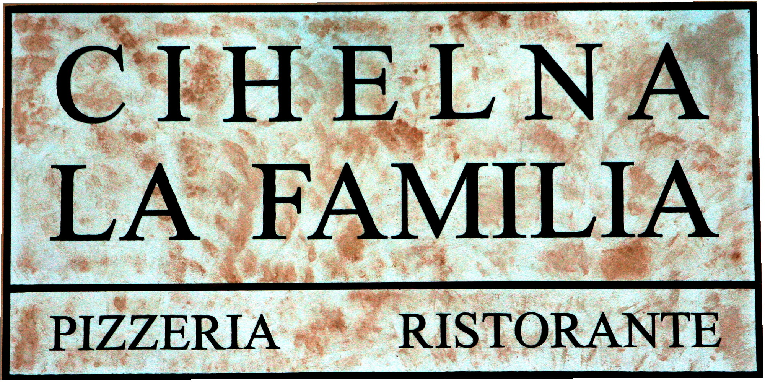
FRESH HOMEMADE PASTA / PASTA FRESCA
(we make our own pasta - fresh every day)

101 SPAGHETTI ALLA BOLOGNESE 195 Kč
meat ragout with fresh herbs in tomato sauce
with parmesan shavings

102 SPAGHETTI ALLA CARBONARA 185 Kč
Roasted Pancetta with egg, cream and Parmesan shavings

103 SPAGHETTI AGLIO, OLIO E PEPERONCINO 165 Kč
garlic, and chili peppers in olive oil with parmesan shavings

105 FUSILLI AL SALMONE 205 Kč
pieces of salmon in white wine with tomatoes, red onion and ginger

106 FUSILLI MAFIOSI 249 Kč
slices of beef on rosemary with cherry tomatoes, olive oil, chilli, garlic and mozzarella

108 PAPPARDELLE POLLO E SPINACI 195 Kč
chicken breast with spinach, garlic, cream and parmesan

109 PAPPARDELLE CON POLLO E BROCCOLI 205 Kč
pasta with chicken, broccoli, garlic, softened with cream and flavored with gorgonzola cheese

110 PAPPARDELLE VERDI AI FUNGHI PORCINI 209 Kč
pasta with cream sauce, porcini mushrooms, Pancetta and garlic with Parmesan shavings

POTATO GNOCCHI / GNOCCHI DI PATATE

121 GNOCCHI DI PATATE CON POMODORO E POLLO 205 Kč
potato dumplings with chicken in white wine and butter, cherry
tomatoes, pomodoro sauce, chili, garlic, olives, oregano, pickled pepper, garnished with arugula and Parmesan shavings
122 GNOCCHI AI QUATTRO FORMAGGI 215 Kč
potato dumplings with Gorgonzola, mozzarella,
Taleggio cheese, Parmesan shavings and cream
BAKED PASTA / PASTA AL FORNO

131 LASAGNE ALLA BOLOGNESE 219 Kč
pasta baked with meat ragout in tomato sauce,
mozzarella and parmesan

132 GNOCCHI PANNA E SALMONE 219 Kč
potato dumplings baked with pieces of smoked salmon, butter,
spinach, garlic, cream and parmesan

RISOTTO / RISOTTI

141 RISOTTO AL SALMONE 219 Kč
Italian Arborio rice with grilled salmon and arugula,
white wine, softened with cream, garnished with dill

142 RISOTTO AI FUNGHI PORCINI 219 Kč
Italian rice Arborio with porcini mushrooms, Pancetta, softened with truffle oil and sprinkled with Parmesan

BISTECCA
The minimum time of meat preparation is 30 minutes

151 FLANK STEAK 200g 435 Kč
filleted beef belly on crispy iceberg lettuce with Dijos mustard,
cherry tomatoes, radish, mayonnaise and lime juice

152 COSTATTA ARGENTINA 220g 499 Kč
Argentinian Rump steak with gratinated potatoes stuffed with Chedar cheese, bacon and egg

153 STEAK ALLA FATTORIA 250g 549 Kč
beef steak from beef sirloin with egg, Pancetta, roasted corn on the cob and homemade croquettes

MEAT / CARNE

163 COSTATTA ALLA FAGIOLLINI 250g 329 Kč
juicy pork neck roasted on a lava grill
with beans on bacon with mashed potatoes and Viennese onion

164 PETTO DI POLLO CON PARMIGIANO IN VERDE 200g 319 Kč
chicken steak on a lava grill garnished with parmesan shavings, grilled tomato, pesto sauce and creamy potatoes

171 HAMBURGER ALLA CHEF 200g 259 Kč
beef burger with romaine lettuce, fresh tomatoes,
Pancetta, Chedarr, onions, french fries and Mississippi sauce

FISH / PESCE

181 SALMONE ,,TERIYAKI,, 180g 359 Kč
fresh salmon with Japanese Teriyaki sauce, garnished with pink ginger and shrimp, served with jasmine rice

KIDS MENU / MENU DI BAMBINI
We offer a children's menu only for children. It is not possible to order for an adult!

205 CHICKEN FRIED STEAK 100g 109 Kč
with french fries

DESSERT / DOLCI
201 TIRAMISU 115 Kč
traditional homemade italian dessert

202 DESSERT ACCORDING TO THE DAILY OFFER 109 Kč

203 RETRO ICE CREAM CUP 119 Kč
3 types of ice cream according to the daily menu with hot forest fruits, whipped cream, chocolate topping and nuts

HOMEMADE LEMONADES 0,4l 75 Kč
• raspberry, ginger, cucumber

HOT DRINKS / BEVANDE CALDI
221 ESPRESSO MISCELA D´ORO 55 Kč
222 ESPRESSO MISCELA D´ORO DOPPIO (double) 89 Kč
223 ESPRESSO DECOFEINATO (without caffeine) 55 Kč
224 CAPPUCCINO 65 Kč
225 LATTE MACCHIATO 65 Kč
226 ESPRESSO MACHIATO 55 Kč
227 CAFFE ALGERINO 75 Kč
coffee with egg liqueur and whipped cream
228 CAFFE VIENNESE 69 Kč
229 ICE CAFFE with vanilla ice cream 95 Kč
230 CHOCOLATA CALDA 65 Kč
Italian milk white or dark chocolate with whipped cream
232 GROG 75 Kč
4 cl Tuzemák, hot water, lemon
233 0,2 l Mulled wine 95 Kč
red or white wine

TEA / IL TÉ HARNEY&SONS 59 Kč

240 BAGS:

- HOT CINNAMON SPICE
- JAPANE SENCHA
- JASMINE
- POMEGRANATE OOLONG
- CHAMOMILE
- WHITE VANILLA
- GRAPEFRUIT
- ORGANIC ASSAM
- ORGANIC ENGLISH BREAKFAST

241 FRESH MINT TEA WITH HONEY 65 Kč
242 FRESH GINGER TEA WITH HONEY 65 Kč

DRAFT BEER / BIRRA ALLA SPINA

257 0,3 l KRUŠOVICE 12% 30 Kč
258 0,5 l KRUŠOVICE 12% 50 Kč
259 0,3 l PILSNER URQUELL 12% 33 Kč
260 0,5 l PILSNER URQUELL 12% 56 Kč
261 0,3 l CVIKOV 30 Kč
262 0,5 l CVIKOV 50 Kč
263 0,3 l KRUŠOVICE – NA 22 Kč
264 0,5 l KRUŠOVICE – NA 36 Kč

BOTTLED BEER / BIRRA IN BOTTIGLIA

265 0,5 l PILSNER URQUELL 56 Kč

NONALCOHOLIC DRINKS / BEVANDE NON ALCOOLICI

271 0,33 l Coca-Cola, light, zero 45 Kč
272 0,33 l Fanta orange 45 Kč
273 0,33 l Sprite 45 Kč
274 0,25 l Tonic 45 Kč
276 0,25 l Tonic GINGER 45 Kč
277 0,30 l Natura still, sparkling, slightly sparkling 45 Kč
278 0,25 l Fuzetea peach, lemon, green tea 45 Kč
279 0,25 l RED BULL (can) 79 Kč
281 0,25 l Cappy multivitamin, orange, apricot 46 Kč
grapefruit, strawberry, apple, pineapple, pear
282 0,2 l ORANGE FRESH 85 Kč

APERITIVES / APERITIVI
292 1 dcl MARTINY dry, bianco 85 Kč
293 4 cl CAMPARI 85 Kč
294 4 cl STARLINO ARANCIONE 79 Kč
295 4 cl STARLINO ROSÉ 79 Kč

SPIRITS ŽUFÁNEK
297 4 cl plum 85 Kč
298 4 cl pear 85 Kč

DISTILLATES AND LIQUEURS / ALCOLICI
303 4 cl ABSINTH 70% 79 Kč
305 4 cl TEQUILA OLMECA blanco, gold 99 Kč
306 4 cl BECHEROVKA, lemon 69 Kč
307 4 cl RUM BACARDI blanco, black, gold 75 Kč
308 4 cl HAVANA ANEJO blanco 75 Kč
309 4 cl CAPT. MORGEN SPICES gold 85 Kč
310 4 cl RUM DIPLOMÁTICO RESERVA 105 Kč
311 4 cl TUZEMÁK 55 Kč
312 4 cl SÉRUM ELIXIR 99 Kč
313 4 cl GIN BEEFEATER 80 Kč
314 4 cl GIN BOMBAY SAPPHIRE 89 Kč
315 4 cl MINTIS GIN 99 Kč
316 4 cl VODKA FINLADIA 70 Kč
317 4 cl PEPRMINT zelená 45 Kč
319 4 cl JAGERMEISTER 75 Kč
323 4 cl FERNET stock, citrus 69 Kč
324 4 cl BAILEYS 75 Kč

WHISKY & BOURBON
344 4 cl JAMESON, TULAMORE 89 Kč
345 4 cl JACK DANIELS classic, honey 99 Kč
346 4 cl JIM BEAM BOURBON, honey 89 Kč

GOGNAK & BRANDY
354 4 cl METAXA 99 Kč
355 4 cl COGNAC A. DE FUSSIGNY 499 Kč

SEKTY / SPUMANTI
362 0,75 l BOHEMIA demi sec, brut 399 Kč
CHAMPAGNE
371 0,75 l MOET & CHANDON BRUT IMPERIAL 1990 Kč

WHITE MORAVIAN WINE PAVLOV
383 0,75 l MÜLER TÜRGAU - late harvest 485 Kč
384 0,75 l SAVIGNON – late harvest 485 Kč
385 0,75 l RULANSKÉ ŠEDÉ – selection of grapes 485 Kč
386 0,75 l CHARDONNAY – late harvest 485 Kč

RED WINES
390 0,75 l SVATOVAVŘINECKÉ VOC Kobylí 499 Kč
391 0,75 l FRANKOVKA archetyp Michlovský 439 Kč
392 0,75 l MODRÝ PORTUGAL Michlovský 439 Kč
393 0,75 l RULANDSKÉ MODRÉ Vrátil 599 Kč

ITALIAN WINES / VINO DI ITALIA
A selection of Italian wines can be found in the extra wine list

ALKO MIXED BEVERAGES / COCATAILS ALCOOLICI

411 PIÑA COLADA 129 Kč
Bacardi rum Blanca, coconut syrup, pineapple juice, cream

412 APEROL 105 Kč
Aperol, prosecco, soda

418 CUBA LIBRE 145 Kč
Havana Anejo blanco, limejuice, coca-cola, lime

WE ACCEPT FOOD AND PIZZA ORDERS UNTIL 22:00.

